**User Interface**

|  |
| --- |
| Henry Nguyen  [henry_nguyen777@hotmail.com](mailto:Henry.Nguyen1@student.ufv.ca) |

**ABSTRACT**

February 18 2018. This paper describes my approach to User Interface. The paper identifies and addresses the four main goals of the project: (1) it must have a minimum of 5 user interface components; (2) each UI component must control various movements (or states) of your character and/or environments; (3) each UI component must be different types; (4) and at least 2 UI components must be your own custom creating using primitive shapes in addition to using built-in Processing examples.

**OVERALL SUMMARY**

I’ve added UI interface components to every object that I think could use one, including characters such as a button for human object and bird object, and environments such as a slider for rain, snow, and blizzard classes. For modifications that aren’t suggest by a UI component, I added two buttons that lists the details, such as adding trees, changing dog tail speed, and removing flags.

**SIMPLE SKETCH**

**Diagram**

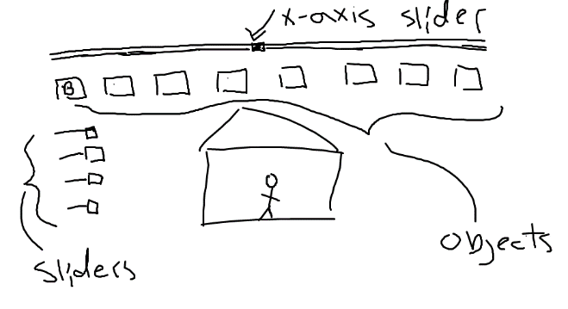

**Figure 1. Sketch of user interface for my project.**

As shown above, I originally had more options for each object but didn’t have enough time to get every detail, however, I do believe I’ve done more than enough. I’ve added a Hint button and Other button to compensate for the UI components I didn’t manage to implement given the time constraint.

**RESEARCH**

In this case, I mostly used the built-in Processing examples, some creativity, and my experience with video games growing up as a reference point for creating the UI. Most games tend to make sure the head-up display (HUD) is around the border of the screen so that it doesn’t cover their focus. My user interface project is based on that idea.

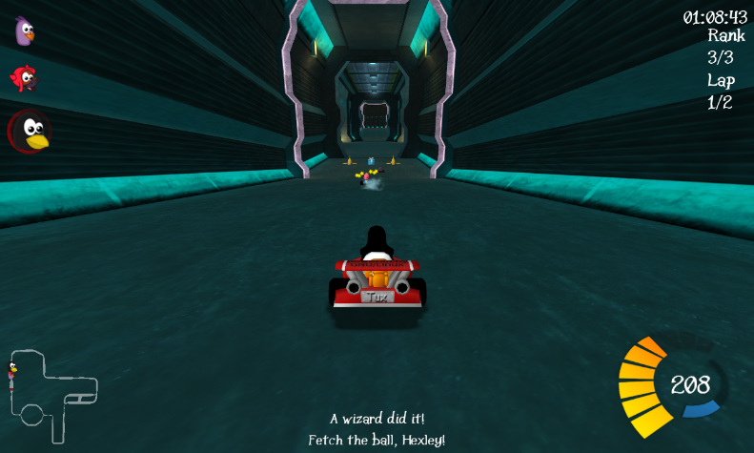

**Figure 2. HUD example. Image from Wikipedia.**

Some of the built-in Processing UI designs I retrieved from are Rollover, Button, Handles, and Scrollbar.

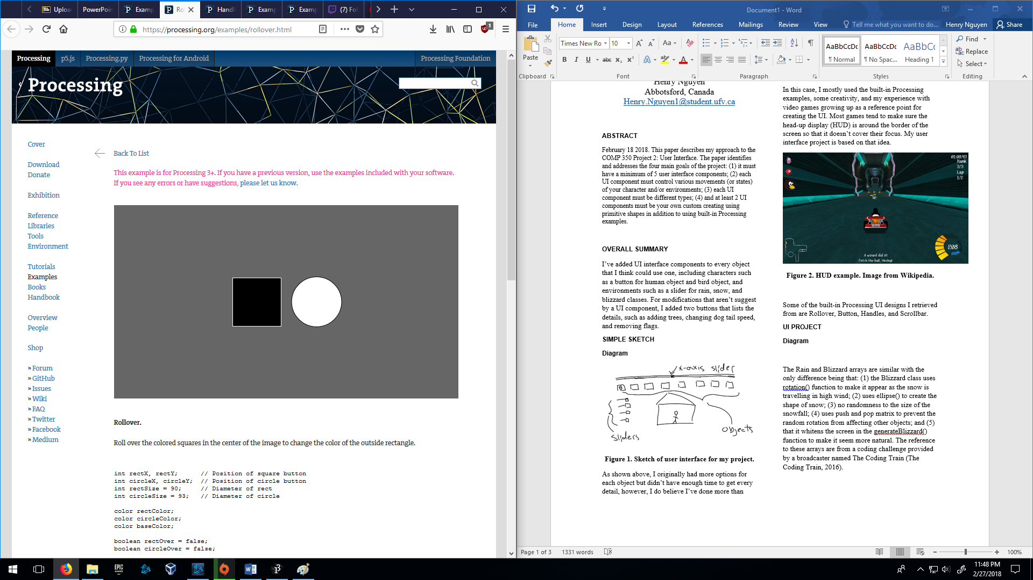

**Figure 3. Rollover example. Image from Processing.**

Using this technique I applied it to all the buttons involved in my project.

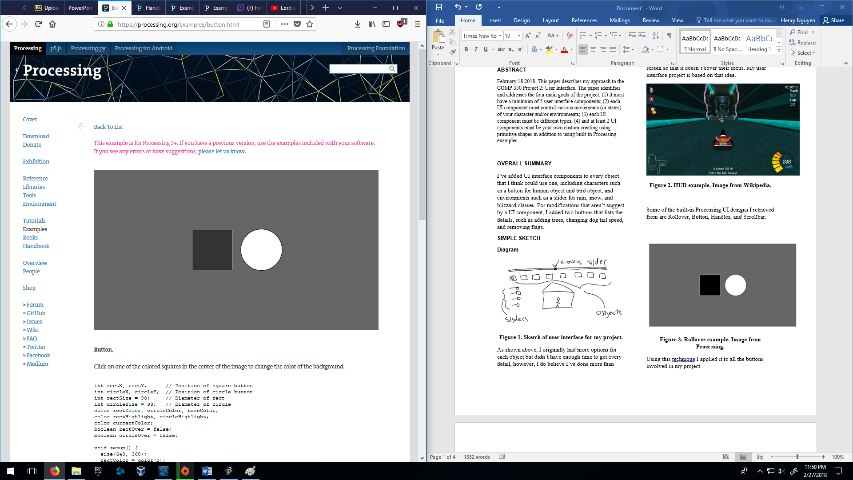

**Figure 4. Button example. Image from Processing.**

For my project, I would modify how the rollovers and buttons apply, such as opening a menu to help the user for my Help button or invert my Bird button as I hover over it. As requirements states to use primitive shapes and built-in processing techniques, I also applied it to most of my buttons.

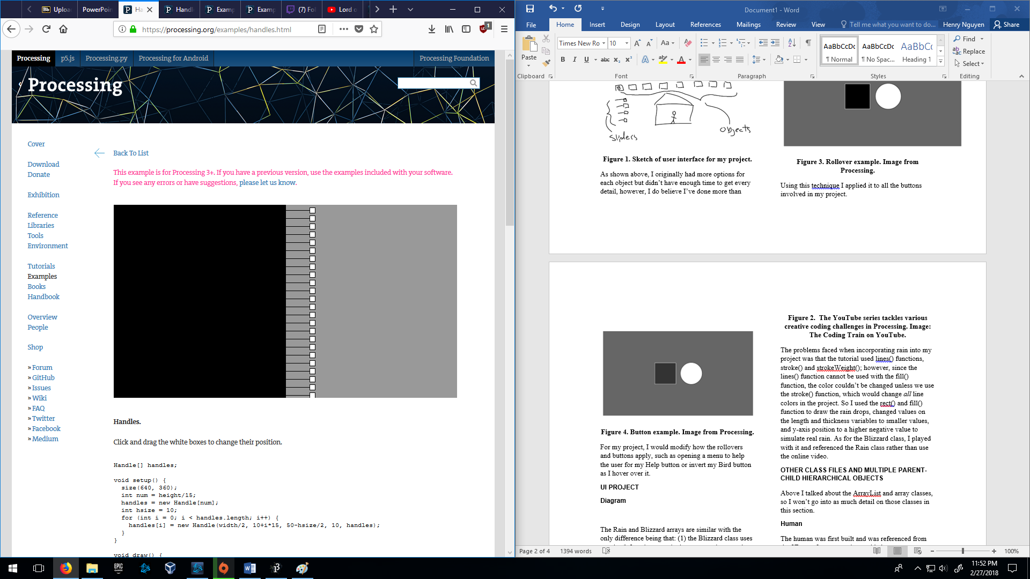

**Figure 5. Handles example. Image from Processing.**

I used the handles technique for my weather conditions, such as increasing speeds or changing size. I also used primitive shapes to change the appearance rather than having lines and a rectangle.

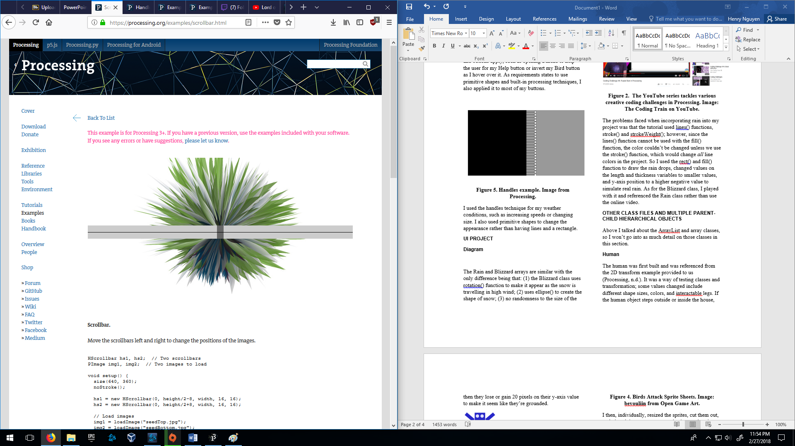

**Figure 5. Scrollbar example. Image from Processing.**

I’ve used this technique but changing values and only having one bar as an alternative means to move around my Human object.

# Bibliography

Processing. (n.d.). *Examples*. Retrieved from Processing: https://processing.org/examples/

Wikipedia. (n.d.). *HUD*. Retrieved from Wikipedia: https://en.wikipedia.org/wiki/HUD_(video_gaming)